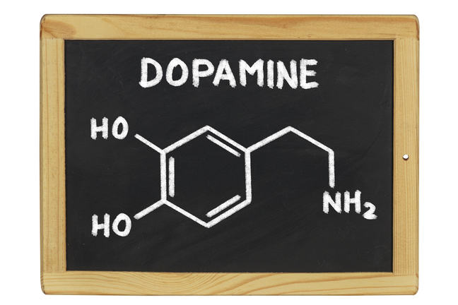

2.7. Dopamine & basal ganglia function
Death of the SNc neurones has consequences for other brain regions. To work out what that is we need to reflect on how neurones in the brain work together as circuits. A key feature of neurones is their ability to transmit information to each other using chemical neurotransmitters and we have just met that SNc neurones produce dopamine as their transmitter. So, in order to work out the consequences of SNc degeneration we need to know which regions of the brain the SNc connects to. It then follows that we need to follow the circuit through various brain structures until we work our way to the part of the brain that would normally make us move.
The key structure that the SNc communicates with is called the striatum (alternatively known as the caudate-putamen) which is the key input structure to the basal ganglia. You may recall that I pointed the basal ganglia out to you in the brain model video – they were the parts coloured red. The striatum then communicates with other structures in the basal ganglia and eventually information travels to the motor cortex regions. So, we can now see how motor control is disrupted following the degeneration of the dopamine-producing SNc cells in this flow chart:
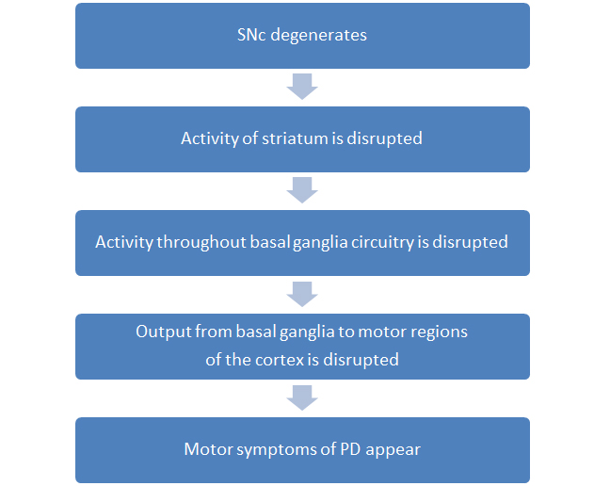
The fine details of the circuitry of the basal ganglia are very complex and not fully understood currently. However, we have a model to help try and explain how the information flows through the basal ganglia both in normal and parkinsonian situations.
In the next video I will show you where the striatum and the other basal ganglia structures are in the brain before drawing a (simplified!) version of the model of information flow through the basal ganglia.
© University of Birmingham

