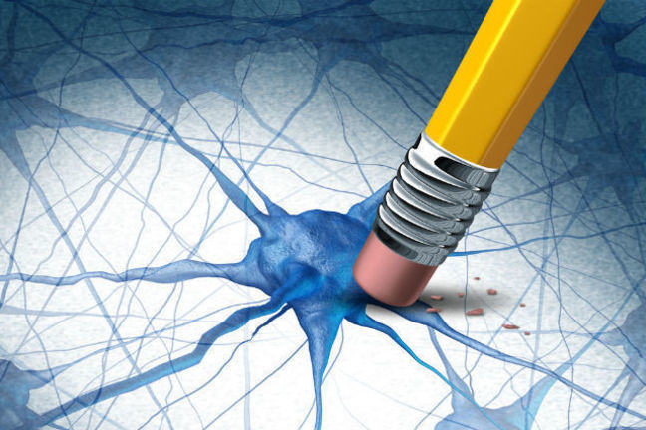

2.4 Case study: Why do substantia nigra neurones die?
One of the areas we haven’t covered yet is what causes these SNc cells to die and why do they seem to be particularly vulnerable. Whilst these are obvious questions to ask, as things currently stand there isn’t a simple answer to either.
Some clues have been gained from studying rare individuals who have an inherited form of Parkinson’s disease. This has helped identify some potential cellular processes that may be defective and result in neurone death.
Two questions then emerge:

• Will the information from the rare genetic cases generalise to people who have no family history of Parkinson’s?

• Why do the SNc cells degenerate when there is no clear genetic cause?
As might be expected, for sporadic cases there appear to be both “nature” and “nurture” components, whereby the two interact to determine whether any one individual develops PD. A number of susceptibility genes have been identified which increase your chances of developing PD but just because you have them doesn’t mean to say you’ll get it. It follows, therefore, that additional factors are required. Long-term epidemiological studies have proposed a number of candidates for these additional factors. For example, exposure to a number of environmental factors such as heavy metals or pesticides or even viral infections may all contribute to the chances of an individual developing PD.

Genetics

Your task:

Find an example of a gene that has been linked to inherited forms of PD and find out, in simple terms, what the consequences of the defective protein produced from the mutated gene are for neuronal functioning.

Environmental factors
One event linked to human exposure to a toxin has had a major effect on our understanding of PD. In the 1980s drug dealers in California were trying to produce a drug related to heroin cheaply. The chemical reactions went wrong and one of the unwanted products was a substance known as MPTP which rendered those who used it parkinsonian in a matter of days. This has influenced PD research in a number of ways; it has enabled us to confirm the role of dopamine and enabled us to produce animal models of Parkinson’s disease to help with the research effort.

Your task:

Look up the history of William Langston who worked out that MPTP was the toxic agent.
In the comments area, discuss the impact that this discovery has subsequently had on our understanding of the pathophysiology of Parkinson’s disease and our ability to generate new therapeutic strategies.
Remember, you can ‘like’ comments if you agree with what’s been said or if you have found something particularly interesting, or you can ‘reply’ to comments to initiate a conversation.
© University of Birmingham

